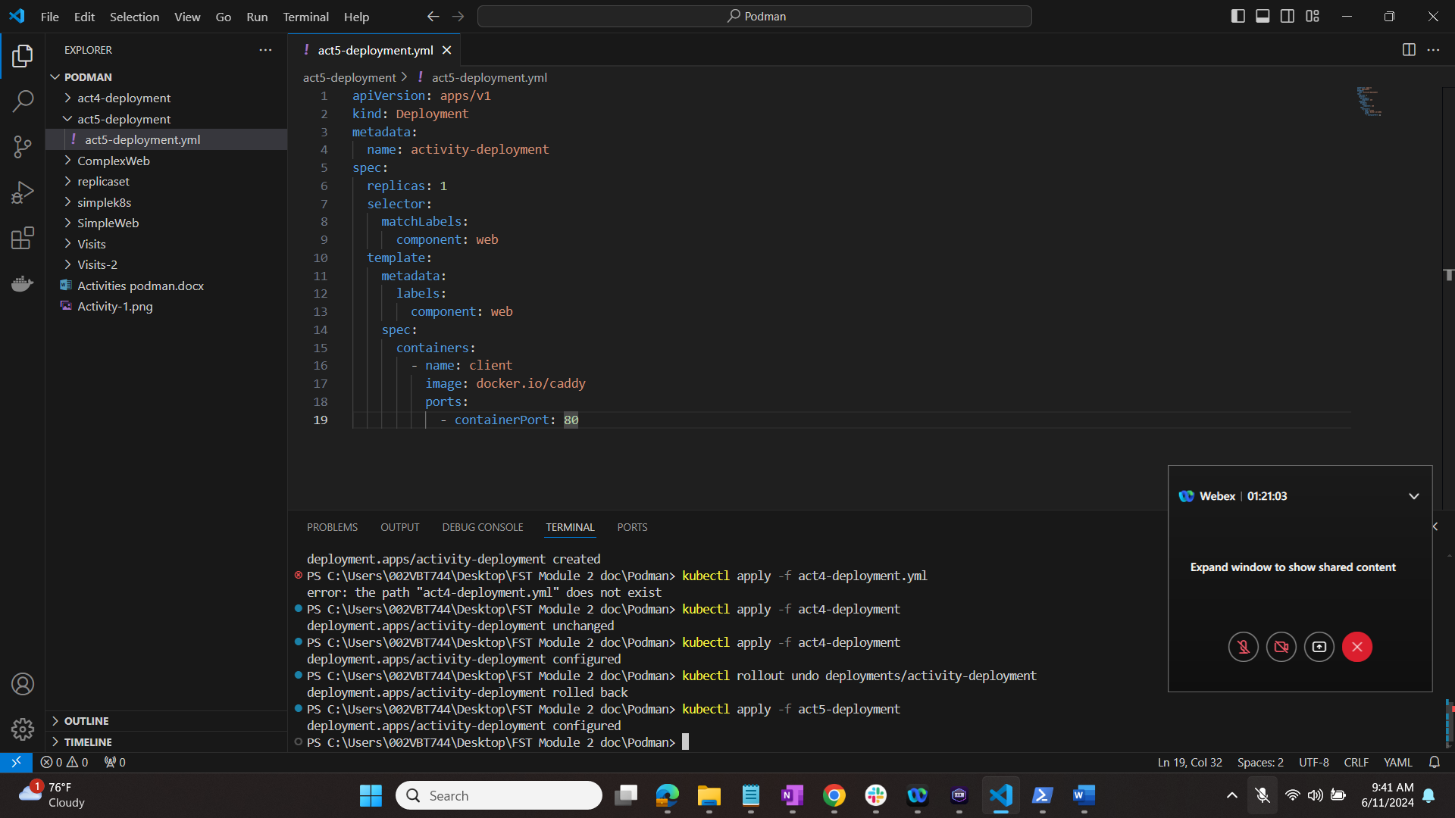

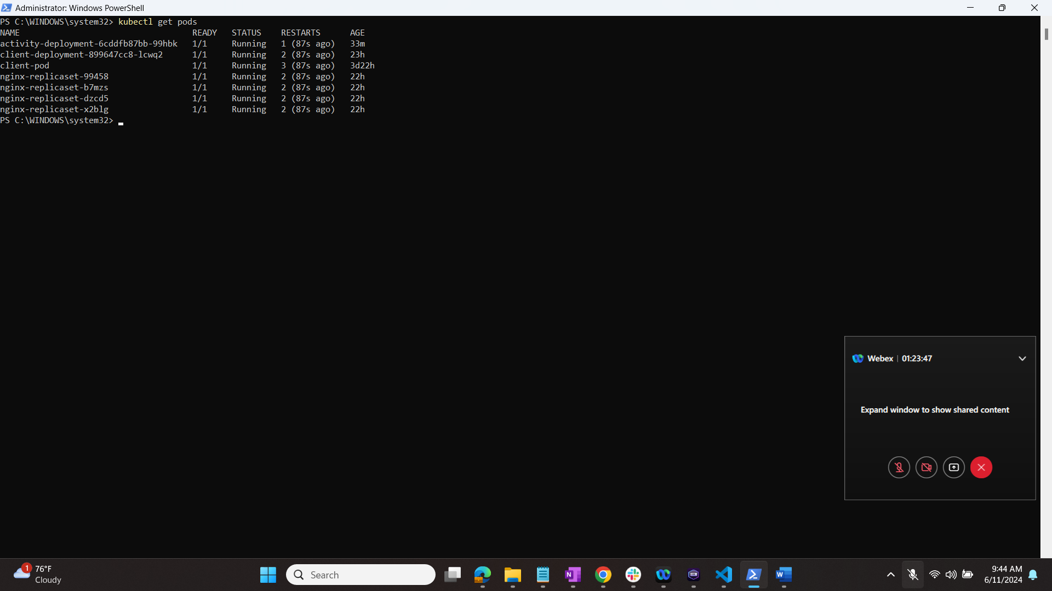

$ kubectl set image deployment/activity-deployment client=docker.io/nginx:latest



